AP CSP Python with CodeX  Mission 1 & 2 Assignment |  | Name:
Getting Started
Welcome to Firia Labs and programming with Python! To get started on your journey, open CodeSpace and log in to your account. If this is your first time on CodeSpace, follow these instructions: [link to slides]
Mission 1 : Welcome to CodeSpace Objectives
Complete Objective 1
Read ALL the information. Take notes in the space provided.
Complete Objective 2
Read ALL the information. Take notes in the space provided.
Complete Objective 3
Read ALL the information. Take notes in the space provided.
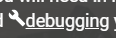
Click on the debugging tool and read the information. Paste a snippet of the definition.

In the debugging tool, scroll below the image and read about the debugger. Paste a snippet of the paragraph that answers this question:
Complete Objective 4
Read ALL the information. Take notes in the space provided.
Take the quiz. How did you do?
Mission 2 : Introducing CodeX Objectives
Complete Objective 1
Click on display and read about it. What is something you learned about display?
Click on audio and read about it. What is something you learned about audio?
Click on LEDs and read about it. What is something you learned about LEDs?
Complete Objective 2
Read ALL the information. Take notes in the space provided.
What are some hints for handling CodeX?
Complete Objective 3
What is a CPU?
What are some common peripherals?
Complete Objective 4
Read ALL the information. Take notes in the space provided. You will connect the CodeX.
Complete Objective 5
Read ALL the information. Take notes in the space provided. You will link the CodeX to CodeSpace.
Complete Objective 6
Read ALL the information. Take notes in the space provided. You will create a new file.
Complete Objective 7
Read ALL the information. Take notes in the space provided. You will add code to your new file.
Take the quiz. How did you do?
Complete Objective 8
Type the code from CodeTrek and run the program.
Complete Objective 9
Click on pics to see all 10 pre-built images. What are some images that interest you?
Mission 1 went over only a few parts of CodeSpace. Spend some time exploring the learning environment. Hover your mouse over the icons to see what each one is called and what it does. When you are familiar with CodeSpace and all its parts, go to the “Label the Parts of CodeSpace” on the next page.

Label the parts of CodeSpace:
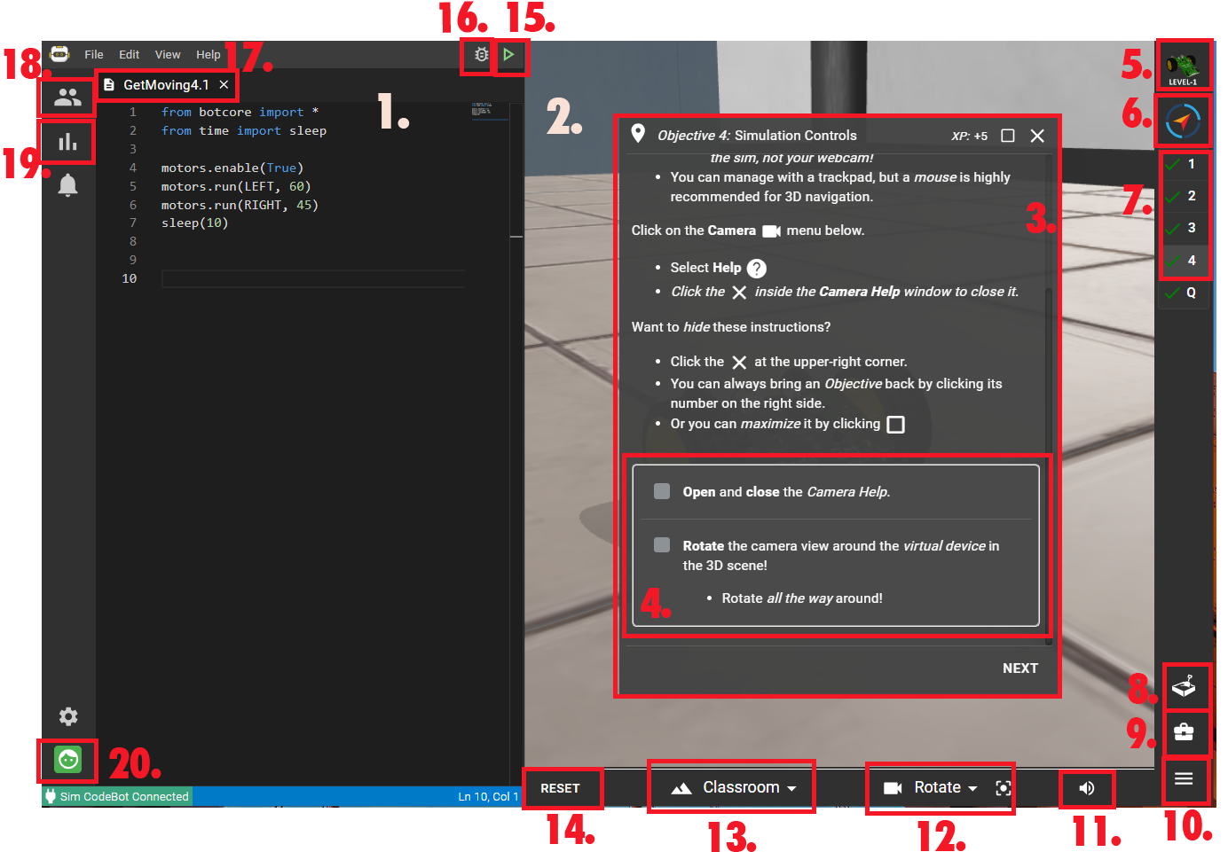
11.
12.
13.
14.
15.
16.
17.
18.
19.
20.

Parts of CodeSpace:
- Goals
- Objectives
- Camera controls
- Debugger
- Select Class
- Text Editor
- Log in / out
- 3D environment
- Filename
- Open console panel
- Reset the environment
- Current Mission Pack
- Run
- Objective panel
- Sandbox
- Progress and contests
- Toolbox
- Current Mission
- Select 3D environment
- Scene volume

